Golden Mask 6

ENTER
COINS 15kHz
110
G.B.
PBOX MED
S. THR. 90
A. THR. 30
BOOST 4
+
39
IRON
FOIL
NICKEL
COPPER
SILVER
User Guide

23

All Rights Reserved!

About the Golden Mask 6 Metal Detector
The Golden Mask 6 is the latest and top-of-the-line addition in the Golden Mask range of metal detectors. The GM6 is the first metal detector of the company to use a real 3-level menu system, the buttons on the front panel are reduced to 5 (9 in the previous model). Three working frequencies are available: 5, 15 and 30 kHz - 5 kHz for relics and large targets, 15 kHz for coin shooting, jewellery and general use, and 30 kHz for gold prospecting, tiny jewellery and tiny/thin coins.
The main and most important improvement in this model is it’s way of functioning - now the GM6 works as the truly analogue top models, with pronounced threshold and real sound response from the coil signal. Deep signals and shallow signals are not equal, the sound response give you real-time information on how deep or how big your target is. The sound is driven by a dedicated DAC chip and a microprocessor, that’s why the sound of the GM 6 is so different from the previous models.
Another great feature ais the four user-modifiable pre-sets, called programs: coins, relics, gold and beach. With 3 click you can switch the program. You can edit the programs and revert to the factory settings, if something goes wrong.
The 6 is engineered to have complex abilities for all type of metal detecting activities and to be a universal tool to successfully answer the high requirements of the contemporary metal detecting amateurs and professionals.
The Golden Mask 6 has the following main features and characteristics:
- High sensitivity and great depth of detection;
- High stability;
- Ease of use;
- Fast recovery speed and target separation;
- Three working frequencies - 5, 15 and 30 kHz;
- Spectrum VDI + target ID for accurate target identification;
- Superb Iron discrimination;
- Rain-resistant control box;
- Collapsible, lightweight and comfortable telescopic carbon shaft;
- Wide range of multi-frequency coils. All MF coils you already have are fully compatible;
- Wireless headphones WS105 or WS106 (included in the package);
- 5 years warranty of the electronics board;
To offer the 5 years warranty, the Golden Mask metal detectors are made with top-level quality components. This guarantees a long life of your machine and many happy moments for you, enjoying your hobby.

Main Parts and Assembly
Turning on and off the detector
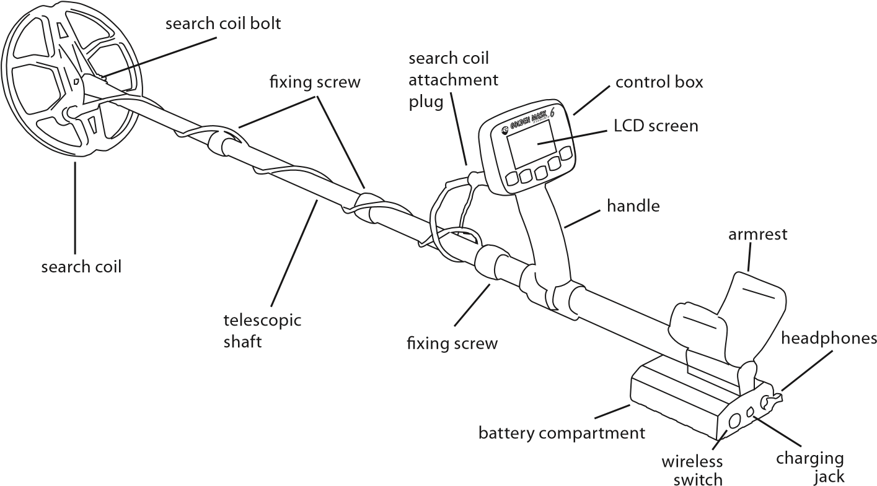jack
Your Golden Mask 6 comes to you in a box that contain: the detector with telescopic carbon shaft and pre-installed 10 x 2500mAh AA NiMh rechargeable batteries (this is subject to change, while shipping batteries in some destinations is prohibited), a search coil by your choice, wireless headphones, smart charger, warranty card and invoice. There is nothing special assembling the detector. You have to attach the coil to the lower stem of the shaft, using the supplied plastic bolt and screw (they are already on their place), then attach the coil cable to the main unit. Using the supplied velcro straps, tighten well the coil cable to the shaft and you are ready to go. Pay special attention on the coil side - the cable has to be set outside the active zone of the search coil.
To extend the telescopic shaft, start from the first section by the side of the coil. Turn the fixing screw counter clockwise, pull the search coil gently to the full extent of the carbon pipe and then fix the section by turning the fixing screw clockwise. Do the same with the second section. Check if the length is enough, if not, extend the third section to match the desired length.
WARNING: The third section of the shaft can be pulled out completely from the handle part, but we do not recommend it, because a plastic shim inside the locking screw could be lost or damaged. Please, be sure to have a minimum of 15 cm (6 inch) of the third section inside the fixing screw of the handle section, otherwise the stem will not be stable enough and could be broken, especially if a large coil is used.
To turn on the detector, hold the ON/OFF button for 2 seconds - a world map graphic will appear on the screen. From this stage to operation stage around 10 seconds are required for the detector software to load.
To turn off the detector, press and hold the ON/OFF button. A screen with HOLD TO TURN OFF will appear. Hold until a POWER OFF screen appears and then release the button.
WARNING!
THIS PART IS VERY IMPORTANT, READ IT CAREFULLY!
When you turn on the detector, the coil must be at least 50 cm (20”) high from the ground, and far from any metal objects. After the software loads, the detector performs a RESET of the electronics to pair the detector with the coil, according to the surrounding
temperature and electromagnetic fields (if any).
You can manually do a RESET at any time by short-pressing the ENTER button.
A RESET is REQUIRED every time after you change the Program, the working frequency or the Power Box settings.
If the surrounding temperature is changing quickly, the detector may become nervous. In this case you should perform a reset prior of making any other changes, the reset resolves the problem in 99% of the occasions.
67

Operating the Golden Mask 6
The Golden Mask 6 is designed to be as simple to operate as possible. The Golden Mask engineers worked hard to simplify the controls and make your hobby a real pleasure, not a struggle with endless functions and menus.
The controls of the detector are 5 buttons on the front panel of the control box and a switch on the back side of the battery box to control the wireless transmitter for the wireless headphones.
In working mode, on the LCD screen are shown all the working parameters of the detector, the Target ID number and the Spectrum VDI scale, where a graphic of the target signal response is shown to help identifying the target detected.
On the graphic you can see the LCD screen indicators. Buttons will be explained later.
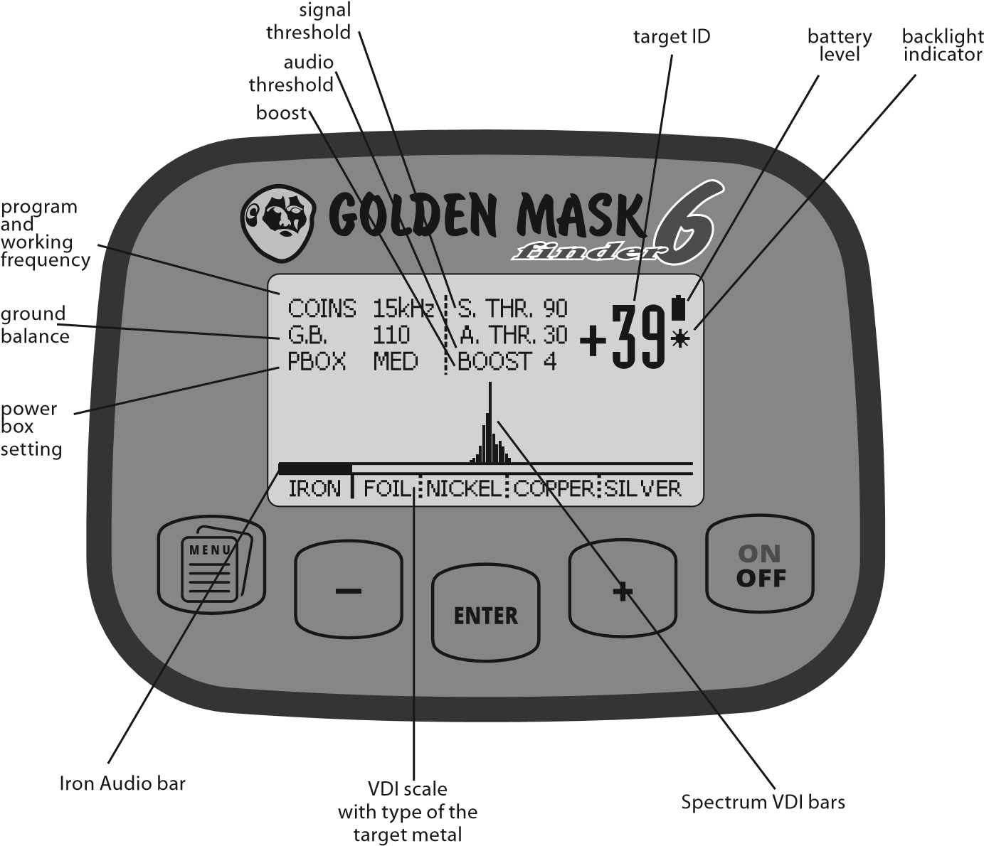

Buttons and Menu Explained
The Golden Mask 6 uses a 3 level menu system, driven by 4 buttons. The left column is the first level, the middle column is the second level and the third column is the third level. Note that some of the positions from the second level do not have options to set in the third level of the menu.
The machine has 5 buttons, but the most-right one is used only for turning on and off the detector and for turning on and off the LCD backlight.
To enter the menu, you have to click the MENU button once. Now you see the main menu screen with PROGRAMS label selected - this is the default state when you press MENU.
ENTER
PROGRAMS
FREQUENCY
POWER
THRESHOLD
DISC.
SOUND
G.B.
COINS
RELICS
GOLD
BEACH
To navigate the menu, use the MINUS button to move the marker up and the PLUS button to move the marker down. With the ENTER button, you enter the selected menu. The active position from the second column is marked by an arrow.
If you’re on the top row of the first level of the menu and move the marker up (with the MINUS button), or if you are on the bottom row from the left column and move the marker down (with the PLUS button), you will enter the PROGRAM RESET menu - it is hidden until you access it the way described above.
The menu positions will be explained later, nor we talk about the control.

89
Golden Mask 6 menu system
1st level | 2nd level | 3d level
PROGRAMS | COINS | N/A  Choose the desired program by moving the arrow up or down with the + and - buttons and confirm with ENTER
 | RELICS
 | GOLD
 | BEACH
FREQUENCY | 5 kHz | Shift: 0-8
 | 15 kHz | Shift: 0-8
 | 30 kHz | Shift: 0-8
POWER | PBOX | LOW
 |  | MED
 |  | HIGH
 | BOOST | 0-5
THRESHOLD | SIGNAL | 0-90 (default: 90)
 | AUDIO | 0-60 (default: 30)
DISC. | 1 TONE
 | 2 TONE
 | ALL METAL
 | DISC. DEPTH | 0-15 (default: 10)
SOUND | IR. VOLUME | 0-10 (default: 10)
 | N.F. VOLUME | 0-10 (default: 10)
 | IR. TONE | 0-30 (default: 25)
 | N.F. TONE | 0-30 (default: 25)
G.B. | AUTO
 | MANUAL | 0-200
 | G.B. SENSE | 0-5
 | G.B. STAB. | ON/OFF
FACTORY RESET  (hidden from the main menu) | COINS | RESET
 | RELICS
 | GOLD
 | BEACH
Enter the menu system and exit the menu to show the main (working) screen.
Moves the menu marker up.
Lowers the chosen setting in the menu.
Moves the discrimination (iron audio) bar border to the left.
When in working mode, performs a RESET of the electronics.
When in MENU mode, confirms/enters the position with the marker.
Moves the menu marker down.
Increases the chosen setting in the menu.
Moves the discrimination (iron audio) bar border to the right.
Switches the detector On and OFF.
Switches the LCD backlight On and Off by a short click.
Enters the LCD contrast control by short click and immediately + and -
Here are the five buttons with their functions.
On the right page you see the entire menu system of the Golden Mask 6.
1011

Some Base Info You Have to Know

Target ID and Spectrum VDI
Target ID and Spectrum VDI are two ways for target identification.
Target ID is a number, shown at the top-right corner of the LCD display. Ferrous targets are shown with negative numbers (e.g. -5), while nonferrous targets are indicated with positive numbers. The border between ferrous and nonferrous targets is 0. The more a target is placed to the right end of the VDI scale, the greater the Target ID value. And vice-versa.
The Spectrum VDI is in fact a graphical presentation of the real signal, returned by the detected target. It contains a great volume of information about the target, so experienced prospectors could easily guess what’s under the coil only by looking at the Spectrum VDI graphic. The graphic itself consist of thin bars with different height, placed above the VDI scale. The position of the bars left/right on the VDI scale depends on the metal type. The height of the bars depends on the signal strength - the stronger the returned signal, the longer the bars. Fewer and longer bars mean strong signal and big/shallow target.
Stretched left-right graphic means deep and/or multi-metal alloy or rusty iron target.

Discrimination and Iron Audio explained
The Golden Mask 6 has great discrimination with Iron Audio discrimination function and separate ferrous and nonferrous tone and volume settings, so the user could move the discrimination border and reject targets. The default value for the audio discrimination is 0 (zero) - at the border between the ferrous and the nonferrous metals - Iron and Foil on the scale. Targets bellow this border are shown with negative values, targets above this border are shown with positive numbers.
The Iron Audio setting is shown with dual color bar just bellow the Spectrum VDI scale.
The black part of the Iron Audio bar shows targets that will sound as ferrous or rejected (depending on the discrimination mode setting), while the white part shows targets that will sound as nonferrous in Two-tone mode or will not be masked in Mono-tone mode.
Why do you need this? For example, if you are on an ancient settlement where you expect to find tiny coins or small jewellery pieces, you could push the Iron Audio discrimination a little bit at left to be sure these small targets will not be discriminated. Or if you’re on a place polluted with lots of aluminium foil, you can rise-up the Iron Audio discrimination to reject the foil and the detector indicates only targets from Nickel to Silver.
Be aware, that if you reject the foil, you will probably reject also some small targets made from low-conductive metals as Gold. We recommend that Iron Audio stays at zero, especially if you’re a novice metal detector user. If you’re experienced enough, you could push

G.B. 110 A. THR. 30 +58 COINS 15kHz S. THR. 90
PBOX MED BOOST 4
IRON FOIL NICKEL COPPER SILVER
Graphic from a medium-size copper coin at medium depth
G.B. 110 ^{A. THR. 30} +62 COINS 15kHz S. THR. 90
PBOX MED BOOST 4
IRON FOIL NICKEL COPPER SILVER
Graphic from a medium-size copper coin just under the coil
G.B. 110 A. THR. 30 +2 COINS 15kHz S. THR. 90
PBOX MED BOOST 4
IRON FOIL NICKEL COPPER SILVER
Graphic from a small rusty sheet iron at small depth
G.B. 110 ^{A. THR. 30} -10 COINS 15kHz S. THR. 90
PBOX MED BOOST 4
IRON FOIL NICKEL COPPER SILVER
Graphic from a big iron at medium depth
the Iron Audio border a little bit to the left to hear some weak/deep signals that could be cut-out with the default setting, depending on the soil conditions.
To set the Iron Audio value, simply push the - and + buttons, while the machine is in search mode - the black part of the Iron Audio bar will move left or right and a number value appears at the top-left corner of the LCD display. As it was said above, the default value is zero.

Search Coil Choice Considerations
Selecting the right coil for the particular search conditions is essential for your success.
Fortunately, Golden Mask offers a wide range of coils to cover virtually all types of search. Here are some facts you have to consider choosing your search coil:
- Small coils are better on small targets, but they are quite good on large targets too;
- Large coils are good on large targets, but they are not so good on small targets;
- Round coils have better target separation abilities that elliptic coils with similar size;
- Choose small coils for high working frequencies and large coils for lower working frequencies. For example, it’s not a good idea to choose a 12” coil to work at 30kHz.
- Elliptic coils have better ground coverage, and this is their main advantage over round coils.
- For very mineralized soils there are specialized coils like the Fighter or the new and universal Fighter S coils.

1213

The Menu
The Golden Mask 6 uses a 3-level menu system that allow for fast settings change. We will explain every setting of the menu and how it affects the search results.

PROGRAMS
The Golden Mask 6 has four programs to quickly switch different set of settings or to easy start a search without having to set all the settings individually. The four programs are: COINS, RELICS, GOLD and BEACH. To use a program, move the arrow up or down to select the desired program, then confirm with ENTER. That’s all. When in working mode, the selected program is visualized on the main screen, at the top-left corner. All the program are user-modifiable. You can modify the current program changing all the parameters. Your changes will be saved and resumed after you restart the detector.
If something goes wrong and you want to return to the factory-saved settings, you shall reset the program. To do this, go to the program row of the menu, then go a step up, or go to the last row and move the marker one step down - both ways are correct. Now you’re in the RESET menu, where you have to select a program to reset (with the arrow), then confirm with the ENTER button.
After switching the programs, you shall perform a RESET!

FREQUENCY
The Golden Mask 6 could work at 3 frequencies - 5, 15 and 30 kHz. This makes the detector a truly universal machine that will cover all the needs of a contemporary prospector.
In the menu, after each frequency, you will see a number at the third level of the menu. This is the so-called “frequency shift” - a slight change in the main frequency that helps eliminate EMI influence of interferences from other detectors nearby. The number could be set from 0 to 8, the default is 4. Just change this number until you find the best value at which the machine has best stability.

5 kHz
This is a frequency suitable for relic search mainly, but usable also on highly mineralized ground. To make use of the low frequency capabilities to penetrate deeply in the ground, a large coil shall be used. Be aware that at this frequency, you will easily miss some tiny targets or targets made from low conductive metals or alloys.

15 kHz
This is the main and universal metal detecting frequency, that you shall use always when possible. Perfect for coin shooting, jewellery, beach and so on, but quite good also for relic hunting and gold prospecting (when you look for relatively large nuggets). This frequency works good with all Golden Mask coils, except the largest one to date - the 12.5x15 inch, that shall be used at 5 kHz on this machine or 8 kHz on other models, that have 8 kHz working frequency.

30 kHz
This is the Gold frequency. At this frequency the detector is sensitive to low conductive metals as Gold and very tiny targets. The latter could be a problem on trash polluted areas, so this frequency should be used on clean soils. Also, have in mind that at 30 kHz you may experience problems ground-balancing the detector on very mineralized soils, especially if you use a relatively large coil.
After switching the frequency, you shall perform a RESET!

POWER
There are two settings under this position of the menu - PBOX (Power Box) with LOW, MED and HIGH settings, and BOOST with values from 0 to 5.. They are similar, but they are also quite different.
The Powe rBox changes the power (voltage) in the coil itself. Higher voltage means deeper penetration of the electromagnetic waves, but also a higher influence of the soil. So, when you set the PBOX, use LOW on mineralized soils, MED (Medium) on normal soils and HIGH on low-mineralized soils.
The BOOST is an amplification of the signal that comes from the coil. Lower value means lower amplification, higher value means higher amplification. That simple.
Many people, mainly new to metal detecting, set maximum values of the Power and this way they loose stability and report problems with their machines. Their machines are OK, just over-powering the detector always means low stability and poor results. You have a car, right? Do you always drive it at maximum RPM of the engine? No! You drive it according to the road and traffic conditions. The same with metal detectors - you shall set them according to the particular search conditions - soil, moisture, presence of EMI, other machines nearby and so on.
So, when you set the PBOX and the BOOST settings, you shall balance the overall power of your machine.
After switching the PBOX, you shall perform a RESET! The BOOST could be changed without the need of a RESET.

1415

THRESHOLD
The Threshold controls how the detector handles the response from targets. In other words, with the Threshold you could reject or cut-out some weak signals and hear only the strongest ones. This is useful in very polluted areas, where you could reject some of the weakest signals and this way lower the chattering sounds. Of course, this means lower sensitivity to small targets and reduced depth.
The Golden Mask 6 has two separate Threshold settings - SIGNAL and AUDIO.
The SIGNAL threshold controls the response (signal) that comes from the coil. At default it is at its maximum value - 90. Generally you don’t want to loose the weakest signals. But if you have problems with weak EMI, you could cut a little bit of the weakest signals by lowering this setting to 80-85 and have a better stability. Of course, you will loose some weak signals form targets. Another use of this setting is when you want to search only on the surface - lower the value to 10-20 and you will not hear the deepest targets.
The AUDIO threshold limits the audio signal. This setting help to achieve a real, analogue like sound threshold, when you hear a little bit of noise form the detector, but this way achieve maximum overall sensitivity. The default value is 30, values can vary from 0 to 60.

DISC. (Discrimination)
The discrimination is in fact the way your metal detector reacts to different metals and alloys and how it transfers this information to you. There are 3 different modes in this menu, plus an additional setting called Disc. Depth or discrimination depth.

1 TONE
In 1 TONE (mono tone) discrimination mode, the detector produces sound for nonferrous targets only. The signal from ferrous targets (iron) is masked. However, some rusty iron or big iron objects will produce sound, but with practice you’ll learn to securely distinguish the sound response from iron - it is harsh and choppy, not as sharp and obvious as the nonferrous targets sound. The Spectrum VDI scale and the Target ID help to easily identify targets.
With the Iron Audio setting you can control the border of the signal masking. For example, if you don’t want to hear the response from foil, just push the + button to place the border to the right.
The 1 tone mode is good for iron-polluted areas with lots of trash. Pay attention for every sharp signal and try not to pay attention to the chattering from the iron targets.
In 1 tone mode, the detector is a little bit deeper than in 2 tone mode and handles better the deep iron signals.

2 TONE
In 2 TONE or bitonal mode, you hear both signals from ferrous and nonferrous targets. Ferrous targets are indicated with a low sound, while the sound response from nonferrous targets is indicated with high frequency sound. Again, you can control what to be indicated as ferrous and what to be indicated as a nonferrous signal with the Iron Audio setting explained earlier.
The bitonal mode is used if you want to hear the nonferrous and the ferrous metals simultaneously. This is usual for new areas, where the presence of iron could give you valuable information about the place. Many people like to always hear the ferrous targets and this is not a problem with the Golden Mask 6 even in very polluted areas, because of the fast response of the detector. To search in areas with lots of iron trash the Disc. Depth setting should be set at or near the maximum value of 15, the Boost should be set to 1 or 2 and the Power Box to Low - with these settings the detector is even faster.

ALL METAL
In ALL METAL mode the discrimination is completely omitted and the detector is equally sensible to all type of metals. You hear the response from all the metals with a single tone. Identification of the target detected is possible by looking the Target ID numbers and Spectrum VDI graphic on the LCD screen.
In All metal mode your Golden Mask achieves the best depth of detection. The difference with the Mono mode is not as big as you’d like, however there is a difference and this tiny difference may be exactly that additional depth you just need to reach a deep target that other detectors missed. Unfortunately, this mode is not comfortable in iron-polluted areas, but works great on places with few targets and you want to search at the maximum depth possible.

DISC. DEPTH
The Discrimination Depth setting is something different from the usual discrimination settings found on some other brands and models. On the Golden Mask 6 this setting controls the depth the detector discriminates targets at. The lower the value, the closer to the coil the discrimination works. And vice versa. The default setting is 10. Values of the disc. depth can be set from 0 to 15.
So what this setting is used for?
In general, you want your machine to discriminate at the maximum depth of detection. The problem is that the discrimination and the depth of detection are opposites, that’s why the default setting is 10, not 15. In other words, a better discrimination means less depth of detection.
So, what are the lower values for?
1617
If you set the Disc. depth to zero, you will discriminate the objects near the surface and dig all the deep targets. Deep targets are usually ancient, so they could be interesting, even if they are made of iron. Another use of the lower Disc. Depth values is when you search on a mineralized ground. On such ground, all metal detectors tend to indicate deep nonferrous targets as ferrous. With Disc. Depth set to or near zero, these deep nonferrous targets will be properly indicated as nonferrous. In addition, you will have a slightly better detection depth.
With higher values of the Disc. Depth the detector is faster, so if you want maximum recovery speed, use higher values and high working frequency.
If you really don’t know what you shall do with this setting, just leave it at 10 all the time.

SOUND
As you could easily guess, at this position of the menu you could control the sound of your metal detector. There are four settings.

IR. VOLUME (Iron Volume)
This setting controls the sound volume response from Iron targets. The values could be set from 0 to 10, default value is 10. If you are in 2 TONE mode and set this to 0, you will be actually in 1 TONE mode. If you lower this setting to lower values, for example 5-6, this will result in more comfortable search in iron-polluted areas, but this is a matter of personal preference and could be quite different for everyone.

N.F. VOLUME (Nonferrous Volume)
This setting controls the sound volume from nonferrous targets. Values could be set from 0 to 10, default value is 10, and we recommend leave it at 10.

IR. TONE (Iron Tone)
This setting controls the tone frequency for the Iron (ferrous) target response. Values could be set from 0 to 30, default value is 25.

N.F. TONE (Nonferrous Tone)
This setting controls the tone frequency for the nonferrous target response. Values could be set from 0 to 30, default value is 25.

G.B. (Ground balance)
The ground balance is a setting that compensates for different ground conditions. There are soils with no to very strong magnetic properties (the so-called mineralization), and the detector needs to be tuned-up for the soil conditions on the area you are searching in. The properly set ground-balance is essential for the performance of your detector.
There are also conductive soils (salt soils or wet beach sands) that also need ground compensation. There is also a combination of both mineralization and conductivity, which is the worse case - on such ground most detectors cannot be ground-balanced or are running with strongly reduced performance. The Golden Mask 6 is not an exception.
Strong mineralization reduces the working depth of the VLF (very low frequency) metal detectors and their discrimination capabilities, while on low mineralized soils detectors achieve their best working parameters. Again, the Golden Mask 6 is not an exception.
Ground balancing depends also on the coil used. Usually, larger coils are harder to ground balance. Golden Mask offers different search coils for different conditions. The 12” Fighter coil is designed to work exclusively on very mineralized soils, while the new (to date) 13x11” Fighter S (default coil for the GM6) is an universal coil, that works great on every type of soil.

AUTO
As you could guess, Auto ground balance is made automatically. In the Golden Mask 6 this mode is improved and now it’s done fully automatically. Golden Mask 6 has a separate processor unit to perform the ground balance in the best possible way. And it does it quite well, especially on non-mineralized soils and lack of electromagnetic fields. However, the best ground balancing is done manually, especially on mineralized soils, clay soils or wet beach sand.
To automatically adjust the ground balance, select the AUTO mode from the menu and confirm your with the ENTER button. A new screen with numbers will appear.
Now start to move the search coil up and down from around 5 to 30 cm (2—12”), this is known as “pumping” the coil.
5
—30 cm
Look at the numbers - they change up or down. Continue to pump the coil until an AUTO GND COMPLETE screen appears. You’re done!

MANUAL
Manual ground balancing the machine is best, if you perform it the right way. Especially on mineralized soils, a proper manual ground balance could dramatically increase the machine performance and depth of detection.
1819
If you have troubles with the ground balance of your GM6 (this usually happens on very mineralized soils), you should first change to lower working frequency. This almost always solves the problem. If not, decrease the BOOST and/or the Power Box values until you are able to successfully ground balance your machine. Remember: the proper ground balance is essential for the performance of every metal detector!
ATTENTION!
The Ground balance must be performed on a place free from metal objects!
The manual ground balance should be made while the detector is in bitonal discrimination mode - it is easier to balance while hearing low and high sounds. When you become experienced with your machine, you will be able to ground balance in every disc. mode.
To manually ground balance your detector, select the MANUAL option and confirm your choice by pressing ENTER. A screen with numbers will appear (the same as with Auto ground balance). Now start to pump the coil exactly like you do it with Auto ground balance. If the machine is not balanced, you will hear a sound while the coil is going up or down. The goal is to change the numbers on the screen (by pressing the - and the + buttons) until the sound disappears or is slightly audible but equal with the movement of the coil in both directions. If the sound is present while the coil goes up, you should increase the numbers and vice versa. When the sound from the coil movement disappears, the detector is ground balanced. Press the ENTER button to enter the working mode and you are ready to go.
To make it easier, especially on places you’ve never being before, it is a good idea to start with Auto ground balance, then switch to Manual and fine-tune the ground balance.
WARNING!
Every time after switching program, frequencies or changing the Power Box level, a new ground balance must be performed!

G.B. SENSE
This setting controls how the detector “sees” the ground while performing an AUTO ground balance. For example, on low-mineralized soils you should increase the sense, so the detector senses properly the soil and performs the auto ground balance correctly. The rule for this setting is: on mineralized ground, keep the value to 0; on very low mineralized soils, set the G.B. SENSE to 5.

G.B. STAB. (GB stability)
This setting controls the stability of the detector over the ground. What does this mean? The soil is not equally mineralized in your search area. So when there is a change in the magnetic characteristics of the soil, the detector could show some instability or false signals. If you set the G.B. STAB setting to a higher value, the detector will be more stable. So why don’t you just keep this to the maximum setting and have a super stable machine? Because increasing the G.B. STAB value leads to lower depth of detection. This setting shall be set according to the soil conditions. On low mineralized soils you should keep the value to 0, on very mineralized soils you should set this to 5.

Mineralization
You can judge the mineralization level of the ground you are on by looking the number at which your Golden mask 6 is ground balanced. See the table below
Frequency | Ground balance numbers and mineralization level
5 kHz | 0-30 : high mineralization | 30-130 : normal mineralization | 130+ : conductive ground
15 kHz | 0-40 : high mineralization | 40-130 : normal mineralization | 130+ : conductive ground
30 kHz | 0-50 : high mineralization | 50-130 : normal mineralization | 130+ : conductive ground

Turning-on the backlight
To turn-on the LCD screen backlight (for search when it’s dark), just short press the ON/ OFF button once and wait until the backlight is lit and the light icon appears.
To turn the backlight off, short press the ON/OFF button once. As simple as that.
When the backlight is activated, a small icon appears below the battery icon on the main screen to show you the backlight is on.

Controlling the LCD screen contrast
You can change the LCD screen contrast. To do this, short-press the ON/OFF button, then immediately press the - and + buttons within 3 seconds after you’ve pressed the ON/OFF button. If you don’t press any button within 3 seconds, the backlight will be activated or deactivated.

Using the wireless headphones (except Light version)
Your Golden Mask 6 is delivered with wireless headphones WS105 or WS106 - you choose the model while ordering. The wireless transmitter is integrated in the battery compart-

2021

ment of the detector. At the backside of the battery compartment you will find a small switch that routes the sound signal to the speaker or to the wireless transmitter.
WS
SP
To use the wireless headphones, you just switch to WS position and the sound goes to the wireless transmitter. Now you have to switch-on the headphones by pressing and holding for 2 seconds the on/off button. When the headphones are ready to work, a red light will start to blink.
The WS105/106 headphones are operated by the three buttons on the right earphone: on/ off, volume+ and volume-. The three other buttons on the left earphone are not used.
ATTENTION!
When using the WS headphones, the sound volume on the detector shall be set to 10, the sound volume on the headphones shall be controlled by the headphones buttons!
NOTE: The Light version of the detector is delivered without wireless headphones and wireless transmitter. It does not have the WS/SP switch.
The detector and the wireless headphones are factory-paired. You cannot use other brands, only the Golden Mask WS headphones will work.

Pairing Golden Mask WS headphones with the detector
If, for some reason, the detector and the headphones are unpaired, or you just purchased new WS headphones, please follow this procedure to pair them with the detector:
- Set the sound switch to speaker (SP)
- Turn-on the detector
- Turn-on the headphones and place them close to the battery box.
- Switch the detector to wireless sound (WS) mode.
- Short-press the power button of the headphones - you have 8 seconds to do this from the moment you’ve switched to WS mode.
You’re done.

Charging the headphones battery (except LITE version)
The wireless headphones are powered by an internal irreplaceable battery. The headphones are charged through an USB cable (supplied within the package) by connecting it to the supplied wall socket charger, to an USB adapter or by connecting it to the USB port of your computer. A phone charger could be used as well. The charging process is indicated by a green light on the headphones. When the light turns off, the charging is complete and you can disconnect the USB cable and start using the headphones.

Using wired headphones
The detector has a standard 6.35 mm | 1/4” headphones jack to plug-in wired headphones.
The sound module of the detector is engineered to use a large gamut of contemporary STEREO headphones with impedance of 50Ω or higher. Of course, metal detecting dedicated headphones will work and are preferred because of their built quality, they are usually of high impedance, so will work properly on the Golden Mask 6.
WARNING!
Never use headphones with MONO jack! Never use nonstandard headphones or headphones designed to be used with special equipment, for example military equipment - this could damage the sound module of the detector.
Using headphones with 3.5 mm jack + adapter is not recommended - most adapters are junk and may cause malfunctions on your detector. Some adapters may cause short circuit on the sound output module and damage the detector sound amplifier.

Charging the detector batteries
The Golden Mask 6 is delivered with pre-installed 10 x 2500mAh 1.2V AA-size NiMh rechargeable batteries (except the LITE version). The batteries have a life of around 300 cycles charge/discharge.
You can replace the supplied batteries with any standard-size NiMH rechargeable batteries of size AA. You can also use standard AA 1.5V alkaline no-rechargeable batteries.
To charge the detector batteries, connect the Golden Mask Smart charger jack to the charging port of the detector on the backside of the battery box. A red light will be lit on the charger. After the charging is complete, the light will turn to blue colour. You can now disconnect the charger and start using the detector.
2223
ATTENTION! Do not turn on the detector until the charging process is finished and the charger is disconnected! Otherwise the detector electronics may be damaged!
WARNING!
Multi-Color Indicating LED
Plug ON  No batteries  Charging Progress  Full charged, trickle on  Short circuit  Battery reverse  Repairing Batteries  NTC thermistor short  Battery voltage too low  Temperature protect | RED:BLUE flash show the charger is ready  BLUE  RED  BLUE  RED BLINK QUICKLY  RED BLINK QUICKLY  RED BLINK SLOWLY  BLUE BLINK SLOWLY  RED:BLUE:YELLOW BLINK ALTERNATELY OFF
Specifications of the smart charger
INPUT UNIT:  Rated Voltage: AC110/220Vl  Voltage allowed: AC90—265Vl  Rated Freq: 50/60Hzl  Rated Current: 100mA (220V full load):  200Ma/100V  20mA (220V no load)  Max Current: 150mA (220V full load)  30mA (220V no load)  OUTPUT UNIT:  Ratedl Voltage:Automatically adjust from  6V—15V  Max voltage (with no load): 20V  Rated Current: 500mA (450mA---600mA)  Trickle Current: 35--50MmA (Pulsel ratio 1/20  +10mA)  Short Circuit Current: 10—20mA  Battery repairingl Current (Voltage less than 6V):  50-100MA |  | CONTROL UNIT:  V Detect: D -l -5mV  V Detect: 50—65SD 0  Temperature protect: Power Supplier IC =l 150°C  Temperature protect (optional): Battery package 45—55°C  Using 10K MF52 NTC, B=3950  Battery numbers: 5—10 PCs series connected  Pulsel ratio: 31/32 512mS/Pirode  Timer: 6 Hours  ENVIRONMENT:  Ambientl Temperature: -10—40°C  Ambient Humidity: 30%—85% Storagel Temp: -20 —70°C  Storage Humidity: 30%—90%
Never try to charge non-rechargeable batteries! Do not connect the charger to the detector while inside the battery box are installed non-rechargeable batteries! Such action will cause fire!
When the power from the batteries reaches the minimum level, required by the electronics to function properly, the detector will emit a BEEP sound, even if the battery indicator still shows the batteries are not completely discharged!

Some advices
You can buy additional coils with different size and shape from 13 cm to 32x38 cm. The GM6 is compatible with all multi-frequency coils produced by Golden Mask. These have an orange or yellow spot on the cable protector at the coil end. Single-frequency coils do not have the same orange/yellow spot or have a white one.
Do not try to test the detector at home - in every house or even far from a house there are always too many electromagnetic interference (EMI) fields that will disturb the detector and you may think something’s wrong.
On sites with not too many targets, try to use the ALL METAL mode - this will give you 2-3 cm more depth. If you cannot get used with All metal mode, try to use the 1 TONE mode. On mineralized soils, decrease the Boost and the Power Box settings until the detector becomes calm. On strongly mineralized ground, a low value of the Boost very often gives you more depth and more precise discrimination.
Try to swipe the coil near the ground, but without touching it. Do not move it too slow or too fast. With practice, you will find the appropriate speed.
Pay attention on the sound. With practice you will learn to successfully distinguish different sounds. Some experienced detectorists can distinguish different type of targets without even looking on the screen. For example, you can easily distinguish the sound from a coin and a lead bullet, just have to listen carefully. But to do this, you will have to practice a lot. This is the same as with car driving - remember your first days driving? Respect the private property. Do not search in private property without permission - this could lead to serious legal, financial or other type of punishment.
Respect the law in your country about the protection of historical heritage and archeological sites. In all countries in Europe it is strictly prohibited to do metal detecting on or nearby sites.

24

Technical Specifications
Operating Frequency | 5, 15 and 30 kHz with frequency shift
Ground Balance | Manual and Auto
Search Mode | motion, one-tone all metal, two-tone, one tone with discrimination
Controls | gain, threshold, power box, frequency, search mode, disc. depth, ground balance, volume, tone, backlight, screen contrast
Coil Type | Double D, multi-frequency coils by Golden Mask
Weight (incl. batteries): | 1.4 kg with 13x11” Fighter S search coil
Battery pack | 10xAA, 1.2V, 2500 mAh NiMH rechargeable batteries
Battery Life | minimum 10 hours (with Power Box at High)
Wireless Headphones | Yes, included
Headphones Jack | 6.35 mm - 1/4”
Operating temperature | —10 to +50°C

Cautions
Keep the detector electronics and battery compartment from water and moisture. Be very careful when placing your detector on wet ground - moisture can penetrate batteries and break the electronics inside the battery compartment.
Keep the search coils from mechanical impact - stepping on your coil almost always brakes it, and the warranty does not cover this. The search coils are water-proof. You can wash them or submerge them in water - no problem.
Keep the coil connector from dirt and moisture. The good contact between the coil and the detector is essential for the performance of the machine.
Do not use another charger than the supplied with your machine. Third party chargers may be very dangerous for the batteries and may cause fire.
Do not forget to turn off your detector after you end searching - this could ruin the batteries and the electronics inside the battery box.
Good Luck!

