Golden Mask 1+ UK & Spitfire
User Guide

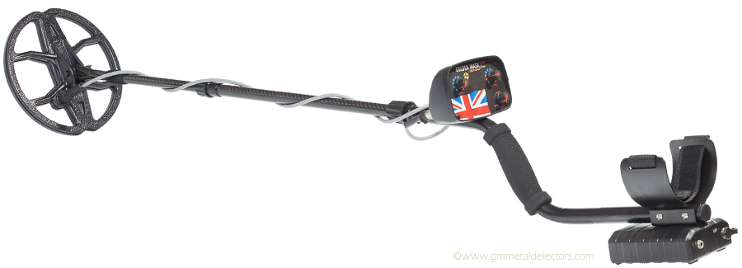

Strong Solutions (2016) Limited, Registered Number 10143198. Trading As
Metal Detectors Online, 1 Bath Hill, Great Yarmouth, Norfolk. NR30 2LQ
www.metal-detectors.online

About the Golden Mask Metal Detectors Series 1

The Golden Mask series 1 metal detectors are very easy to operate, but very effective for finding metal objects in the ground
The 1 series are motion-type VLF (Very Low Frequency) metal detectors, operated by moving the search coil over metal objects.
The two models from the series 1 range differ only by their front covers and operating frequency. The UK version working at 15 Khz and the Spitfire 22 Khz. The most important thing about these machines is that they work with a fixed ground balance. This means you do not have to manually compensate for different types of soil. Just turn on the detector and start searching.
Another great feature of the 1 series is the superb recovery speed. This means the detectors electronics act extremely fast and can separate targets that are very close together. For example, if a coin is laying next to an iron object, you will hear separate sounds coming from each object and you will know there is a coin.

The Golden Mask Metal Detector Series 1 Technical Specifications

Model 1+ UK and Spitfire
Frequency 15 Khz & 22 Khz
Ground Balance Fixed
Search Mode Motion Type
Controls Sensitivity, discrimination & sound volume
Coil Type Double D
Weight (inc Batteries) 1.7kg with a 23x25 search coil
Batteries 10 x AA 1000 mAh rechargeable NiMH
Battery Life Minimum 20 hours
Headphone Jack 6.35 mm – ¼
Warranty Five years for electronics, two years battery charger and coil

Main Parts of the Metal Detector

The Search Coil – this is actually and antenna that emits and receives LF (low frequencies) radio waves. If a metal object is present in the range of the radio signal, the I/O ratio changes and the detector produces a sound. The search coil is connected to the electronics block by a special heavy-duty cable and special gold-plated plug.

S and T stem – the S stem consist of three parts – lower stem, middle stem and handle. The lower and middle stem are made from carbon fibre, while the handle is made from aluminium. The T stem has three telescopic stems and an aluminium handle.

Control Box – contains the electronics board of the detector and the control knobs to control how the detector behaves.

Battery Compartment – a plastic box for the batteries. The detector is powered by 10 standard AA size 1.2v NiMH rechargeable batteries with the capacity of 1000mAH each. They are not soldered and could be replaced at any time. The detector can also operate with standard 1.5v Alkaline batteries. Do not use old style zinc – carbon batteries. On the battery compartment there are two jacks, one for the charger the other for connecting wired headphones. On the wireless version there is an extra button for selecting wired or wireless.

Operating the Golden Mask

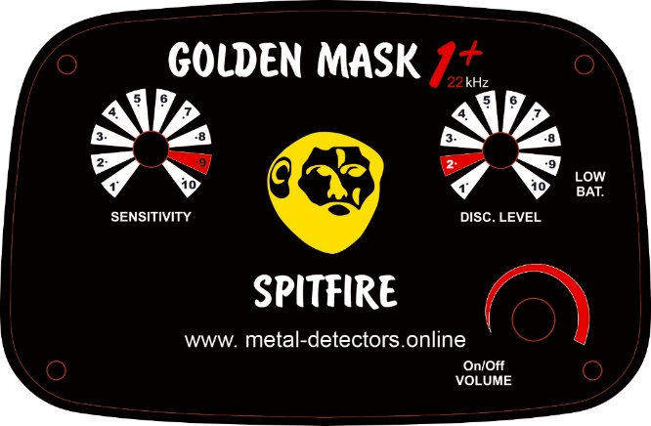

On/Off Volume – by rotating the knob clockwise, you switch the detector on. After turning it on you further rotate the knob clockwise to increase the volume.

Sensitivity – this knob is used to adjust the detectors sensitivity, the recommended level is highlighted in red, but depending on temperature, moisture and electromagnetic fields within the area you are searching. To adjust the sensitivity to the best value, rotate the knob clockwise until you hear the generator background noise, at this setting the detector achieves maximum depth without out loss of comfort for the operator.

Disc Level – the discrimination knob adjusts the level of border between an iron signal and a signal from nonferrous metals. The higher the setting the more conservative the discrimination. It is recommended lower values of discrimination for maximum depth and speed in trashy areas. We recommend setting this value to two since target separation depends on the discrimination. Some experienced users use a zero value while searching on non-polluted areas to achieve maximum depth and speed of target indication, rotating clockwise to identify the target.

Bi-tonal discrimination - the 1+ and the Spitfire both have bi-tonal discrimination, this means the detector indication the ferrous targets with a low frequency sound and the non-ferrous targets with a high frequency. This is useful for general search and if you want to hear the iron also – sometimes iron targets are giving you valuable information about the place you are searching on. If the setting of the discrimination is set to zero, you will hear almost all metals with a high sound for non-ferrous metals and vise versa. If you set the discrimination to a high level, some of the non-ferrous metal are indication as iron.

Low Bat – low battery indicator, when this indicator lights you should recharge or replace the batteries.

Charging Batteries – If the LOW BAT indicator lights, you must turn the detector off and charge the batteries. To do this, simply plug the smart charger into the charger jack on the battery box, then connect the charger to the mains. A multi-coloured led indicates the charger action.

Plug RED,BLUE flash shows the charger is ready
No batteries BLUE
Charging RED
Fully charged BLUE
Short circuit RED BLINKING QUICKLY
Battery reverse RED BLINKING QUICKLY
NTC thermistor short BLUE BLINKING SLOWLY
Batt voltage too low RED,BLUE, YELLOW BLINKING ALTERNATELY
Temperature protect OFF

WARNING-never try to charge non-rechargeable batteries. Such action may cause fire.

When the power from the batteries reaches the minimum level, required by the electronics to function properly, the detector will emit a BLEEP sound, even if the battery indicator still shows the batteries are not completely discharged

Using wired headphones – the detector has a standard 6.35 mm ¼” headphone jack to plug-in wired headphones. The sound module of the detector is engineered to use a large gamut of contemporary STEREO headphones mainly for music listening, of course metal detecting headphones will also work.

WARNING – never use headphones with a MONO jack, or specific headphones such as military headphones, this may damage the sound module in the detector.

Telescopic shaft – to extend the telescopic shaft, start from the first section nearest the coil. Turn the fixing screw counter-clockwise, pull the search coil gently to the full extent of the carbon pipe, then turn the screw clockwise. Do the same with the other sections. Check is the length is enough, if not, extend the third section to match the desired length.

WARNING – the third section can be pulled out completely from the handle section, we do not recommend this as there is a plastic shim inside could be lost or damaged. Please be sure to have a minimum of 15cm of the third section inside the locking screw of the handle section, otherwise the stem will not be stable enough and could be broken.

Cautions – keep the detector electronics and battery compartment from water and moisture. Be very careful when placing your detector on wet ground-moisture can penetrate batteries and damage the electronics inside the housing. Keep search coils from mechanical damage, stepping on your coil will almost certainly brake it and will void the warranty. The coils are water resistant and can be washed and submerged in water.

GOLDEN MASK METAL DETECETOR DO’S AND DON’T’S

- When assembling your telescopic stem, please ensure you have six inches of tube in the handle stem. This aids stability.

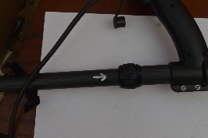

- When detecting, periodically check your three knuckle bolts are tight, with constant movement over time they will work loose.

- Make sure your coil lead is as tight as possible to the stem with the Velcro provided. Velcro the lead as high up to the handle as possible leaving minimum slack.

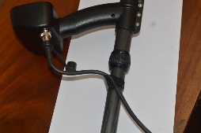

- If there is a loop in your coil cable, make sure it is at the bottom.

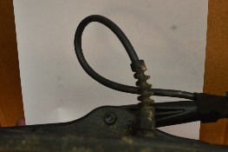

- On the coil lead where it connects to the main unit, you will see a little grub screw, make sure this is tight at all times.

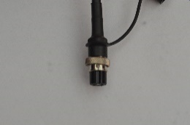

- Never use your detectors as a leaning aid, you will snap the coil holder

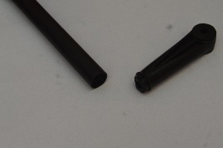

- From time to time, remove your coil protector and clean the actual coil and inside the protector.

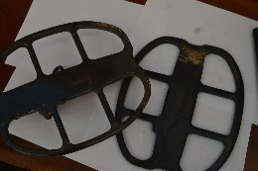

HAPPY DETECTING

